REPORT

ON 5 Day

CAPACITY BUIDING WORKSHOP

OF CSDO STAFF

HELD ON (14-18 JULY, 2009)

ON

“Child & Adolescent Protection from Violence, Abuse, Exploitation & Neglect”

Under
UNICEF PROJECT
2009C
Complied by: Ammara Naseer
Assistant Coordinator
Child & Social Development Organization
SCCI Building, Paris Road, Sialkot.
Ph. : 052-4274781.
9/9/2009

Table of Contents
Sr. # | Topics | Page #
1 | CSDO- UNICEF Partnership | 3
2 | Background / Justification of Staff Training | 3-10
3 | Venue and Participants of the Training | 11
4 | Proceedings  4.1) Day 1 (14 July 2009)  Inaugural Session  - SESSION 1 (ILO CONVENTION 128 and 138)  - SESSION 2 (THE PUNJAB DISTITUDE AND NEGLECTED CHILDREN ACT 2004, JUVENILE JUSTICE SYSTEM ORDINANCE 2000 AND OTHER CHILD LABOUR LAW)  - SESSION 3 (SOCIAL MOBILIZATION, COMMUNITY ORGANIZATION AND YOUTH GROUP FORMATION)  - SESSION 4 (NON FORMAL EDUCATION AND MAINSTREAMING OF CHILDREN INTO GOVERNMENT SCHOOLS)  4.2) Day 2 ( 15 July 2009)  - SESSION 5 (PARTICIPATERY DEVELOPMENT)  - SESSION 6 (PROJECT MANAGEMENT)  - SESSION 7 (MONITORING TECNIQUE)  - SESSION 8 (LIFE SKILL BASED EDUCATION)  4.3) Day 3 ( 16 July 2009)  - SESSION 9 (COMMUNICATION SKILLS)  - SESSION 10 (TIME MANAGEMENT)  - SESSION 11 (MOBILIZATION OF PRIVATE SECTOR)  - SESSION 12 ( PUBLIC PRIVATE PARTNERSHIP)  4.4) Day 4 (17 July 2009)  - SESSION 13 (CHILD RIGHTS CONVENTION)  - SESSION 14 (COMMUNITY BASED CHILD PROTECTION)  - SESSION 15 (SETTING QUALITY INDICATORS)  4.5) Day 5 (18 July 2009)  - SESSION 16 (HORIZONTAL AND VERTICAL NETWORKING)  - SESSION 17 (TEAM BUILDING)  - SESSION 18 (ADVANCE VOCATIONAL SKILLS)  EVALUATION OF THE WORKSHOP AND POST TEST  CLOSING CEREMONY | 11  11  11-12  12  13-14  14  14-15  15  16  17  18  18-19  19  20  20  21  21  21-22  22  22  23  23  24

CSDO – UNICEF Partnership

Child & Social Development Organization (CSDO) Sialkot signed a Project Coordination Agreement (PCA) with UNICEF for the protection of children from the hazardous occupations in Sialkot and adjourning districts. Duration of the first phase of the Project is nine months from May-2009 to Jan-2010.
The overall objective of the Partnership is to create protective environment for children at risk of abuse and exploitation from hazardous occupations by taking protective measures through advocacy, awareness raising, skill enhancement for income generation and monitoring child rights violations. This is being achieved with collective efforts of the service providers and public private partnership to address the poverty based child protection issues.
A comprehensive situation analyses on child protection issues, particularly children involved in hazardous occupations in Sialkot and adjoining districts is being conducted in coordination with the various Project stakeholders.
As key outcomes of the Project are (1) to set up a model of child protection system by creating a sustainable formal and non-formal education and vocational opportunities for the most marginalized children & youth in selected areas and (2) to promote positive environment for public private partnership to strengthen Corporate Social Responsibility (CSR).
The Project is also availing the technical support from various stakeholders such as ILO, TEVETA, Sialkot Chamber of Commerce of Commerce & Industry, District Government particularly Labour, Social Welfare & Bait-ul-Mall, and Literacy Departments.

Background/Justification of Staff Training

A joint Meeting of the CSDO’ Management and UNICEF Team comprised of Mr Mannan Rana, Child Protection Specialist, UNICEF, Islamabad and Mr Shamshad Qureshi, Child Protection Specialist, UNICEF, Lahore was held on 5th June, 2009 in Sheikh Muhammad Auditorium of the Sialkot Chamber of Commerce & Industry to discuss the matters of the Project (CAPP).
On the same date, a separate meeting of the UNICEF Team was held with the President, CSDO and newly appointed staff of CSDO under UNICEF Project. It was decided in the meeting that UNICEF would provide training and exposure visit to CSDO staff hired for the project. After training need assessment, the following areas were identified for the training of staff:-

Sr. No. | Topics
 | Communication Skills
 | Child Rights Convention (CRC)
 | Child Friendly Education System (Punishment, gender bias, abuse)
 | Project Management
 | Development of questionnaire and Monitoring checklist
 | Community participation Theory and Practice
 | Communication interpersonal and community action process
 | Data collection techniques
 | Career counseling
 | Awareness Raising Tools
 | Community/Social Mobilization
 | Participatory approaches
 | Psycho-social
 | Hazardous Occupations
 | Life Skill Based Education
 | Community based child protection system
 | Record Keeping
Orientation/training on the specific project activities:-

- Child Labour clusters identification and children enrollment process in the NFECs.
- Mainstreaming of children
- Community Mobilization/Formation of Community Organizations/TORs/Role & Responsibilities of the Community Organizations.
- Criteria for Conditional Cash Grants
- Advance Vocational Skills (Training of 50 adolescents and less empowered women from CL families to enhance their HH income Mobile Vocation Training units. Linkages development with Govt. and other organizations/Arrangements with TEVTA and NRSP/First Women Bank
- Mobilization of Private Sector, etc.
- Formation of Youth Groups/TORs for YG
- Capacity building of Teachers and Vocational Workers
- Capacity Building of Peer Educators on LSBE
- Monitoring and Reporting Mechanism, etc.

For the capacity building of staff and experience sharing, it was also resolved in the meeting that UNICEF would arrange an exposure visit to Faisalabad, Rahim Yar Khan and Lahore of CSDO’s Project staff.

As per decision of the meeting, the President CSDO requested UNICEF to arrange exposure visit and training of CSDO’s Project staff. UNICEF approved the training program. With the mutual consensus of CSDO and UNICEF the following objectives and 5-Day Training Program were finalized:-

- Objectives
- To make aware of the project staff on international treaties and national/provincial laws related to the child rights

- To build the capacity of participants on Social Mobilization for structured Community and Youth Organization

- To build the capacity of participants on basic indicators of child friendly environment at non-formal Centers

- To build the capacity of Participants on Life Skill Based Education, team building, time management, Peer education, Vocational Trainings, participatory development, Psychosocial support, Community Based Child Protection Systems, networking and other skills for effective execution of the project activities.

- Training Program 14 -18 July, 2009

- Day One
DAY 1 – 14 July
Sessions | Topics | Time | Resource Persons | Methodology
Inaugural Session | - Registration | 0900 – 0930 | Ms. Ghazala Nizami | Performa
 | - Recitation from Holy Quran  - Introduction of Participants/ Pre-test | 0930 - 1000 | Ms. Ghazala Nizami | Participants will share their strong and weak areas of their personalities  The participants will share their expectations
Session 1 | - ILO Convention 182 and 138 | 1000– 1130 | Mr. Abdul Mateen Janjua, Program Assistant ILO-IPEC, Sialkot | Sharing, power point presentation
Tea Break 1130 – 1145
Session 2 | - Punjab Destitute and Neglected Act 2007, JJSO 2000 and other Child Labour Law | 1145 – 1300 | Mr. M. Javaid Iqbal Gill, EDO-CD | Sharing, power point presentation
Session 3 | - Social Mobilization, Community Organization and Youth Groups formation | 1300 – 1400 | Ms. Ghazala Nizami | Interactive discussion, group work
Lunch & Prayer Break 1400 – 1500
 | Continued | 1500 - 1600 | Ms. Ghazala Nizami | Presentation followed by questions
Tea Break 1600 – 1615
Session 4 | - Non Formal Education and mainstreaming of children into government schools | 1615 – 1700 | Ms. Ghazala Nizami | Silent features Interactive discussion, Guideline sharing

- Day Two
DAY 2 – 15 July
Sessions | Topics | Time | Resource Persons | Methodology
 | Refresher of the last day | 0900 – 0930 | Ms. Ghazala Nizami | Question/answers
Session 5 | - Participatory development | 0930 – 1030 | Mr. Mujahid Zahoor, Child Protection Officer, UNICEF, Lahore. | Participants write their views on cards pasted and summing up, Interactive discussion and group work
 | - Continued | 1030 – 1130 |  | Presentations followed by questions
Tea Break 1130 – 1145
Session 6 | - Project Management | 1145 – 1300 | Mr. Arshad Mehmood, R & D Officer SCCI | Sharing, power point presentation
 | - Orientation of Project  - Activities  - Project outputs  - Project Outcomes | 1300 – 1400 | Mr. Mujahid Zahoor | Salient features & interactive discussion
Lunch & Prayer Break 1400 – 1500
Session 7 | - Monitoring Techniques | 1500– 1530 | Mr. Mujahid Zahoor | Sharing, power point presentation, discussion
 | - Continued | 1530 – 1600 |  | Group work, Presentations
Tea Break 1600 – 1615
Session 8 | - Life Skilled Based Education  - Peer Education | 1615 – 1700 | Ms. Ghazala Nizami | Sharing, interactive discussion

DAY 3 - 16 July
Session 9 | - Communication Skills | 0930 – 1030 | Ms. Ghazala Nizami | Participants identify the styles on cards. Cards pasted. Resource Person sums up, Lecture, group work, presentations
 | - Time Management | 1030 – 1130 | Mr. Mujahid Zahoor, UNICEF/Ijaz Ahmed, Project Coordinator, CSDO | Participants write their views on cards. Cards pasted. Resource Person sums up, Lecture, group work, presentations
Tea Break 1130 – 1145
Session 10 | - Continued | 1145 – 1400 |  | Role play
Lunch & Prayer Break 1400 – 1500
 | - Mobilization of Private Sector | 1500 – 1600 | Mr. Ijaz Ahmed, Project Coordinator, CSDO | Presentation
Tea Break 1600 – 1615
Session 11 | - Private Public Partnership | 1615 – 1700 | Mr. M. Javed Iqbal Gill, EDO-CD | Presentation
 | - Recap – What new things have we learnt today? | 1700 - 1715 | Ms. Ghazala Nizami | Each participant writes one new learning on a card. Cards are pasted & summed up.
- Day Three

DAY 4 – 17 July
Session 12 | - Psychosocial support  - How to communicate with children and manage emotions  - Supporting resilience in children  - Structured psychosocial activities with children  - Basics of child friendly centers | 0900 – 1100 | Ms Khawar Sultana/ Ms. Ghazala Nizami | Interactive discussion Role play, sum up Group work, presentations
Session 13 | - The Convention on the Rights of the Child | 1100 – 1130 | Ms. Ghazala Nizami | Brain storming, discussions
Tea Break 1130 – 1145
Session 14 | - Community based child Protection | 1145-1400 | Ms. Ghazala Nizami | Group work, Presentation
Lunch & Prayer Break 1400 – 1500
Session 15 | - Setting Quality Indicators of NFEs | 1500-1600 | Ms. Ghazala Nizami | Sharing power point presentation discussion
Tea Break 1600 – 1615
Session 16 | - Group work | 1615 – 1700 | Ms. Ghazala Nizami
 | - Recap – What new things have we learnt today? | 1700- 1715 |  | Each participant writes one new learning on a card. Cards are pasted & summed up.
- Day Four
- Day Five

DAY 5 – 18 July
Sessions | Topics | Time | Resource Persons
Session 17 | - Horizontal and vertical networking at CO | 0930 – 1030 | Mr. Mujahid Zahoor | Role play and group presentations
Session 18 | - Team Building | 1030 - 1130 | Mr. Ijaz/Ms. Ghazala | Sharing, interactive discussion
Tea Break 1130 – 1145
Session 19 | - Advance Vocational Skills  - Micro Financing | 1145-145 | Mr. Mujahid Zahoor | Interactive discussions on appraisals of skill trainings and sustainable micro enterprises
 | - Evaluation of workshop and Post test | 145 - 1400 | Mr. Ijaz/Ms. Ghazala | Performa
Lunch & Prayer Break 1400 – 1500
 | - Statement by the President CSDO | 1500-1510 | Sh. M. Yunas Ratra
 | - Closing remarks, certificates distribution and group photo | 1510 – 1600 | Mr. Shamshad Qureshi, Child Protection Specialist, UNICEF, Lahore
Tea Break 1600 – 1615

Venue and Participants of Training

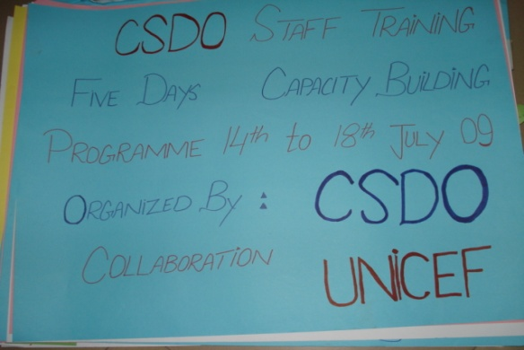
The training was held at Hotel Taj Palace, Sialkot. All the staff members including NFEC teachers hired under the UNICEF Project, Government Officials from Labour and Social Welfare Departments, representative of NGO participated in the training. Mr Mujahid Zahoor, Child Protection Officer, UNICEF, Lahore and Ms Ghazala Nizami, Resource Person were the key facilitators of the training.

Session Wise Proceedings
Session wise proceedings of the training were as under: -

4.1) Day 1 (14 July 2009)

Inaugural Session

Training started with the brief introduction of all the participants. The participants were asked to share their strong and weak areas of their personalities. Ms Ghazala Nizami briefed the participants about 5-day training program. All the participants filled the registration form.
A pre-assessment test was taken from all the participants in order to judge the strong and weak areas of the participants for focusing the training.

Session 1:

ILO CONVENTION 128 and 138

(By Mr. Abdul Mateen Janjua, Program Assistant, ILO-IPEC, Sialkot).

Mr. Abdul Mateen Janjua gave a detailed presentation on ILO Convention 182 and 138 on multimedia projector. The Key points of the lectures/presentation were as under:-
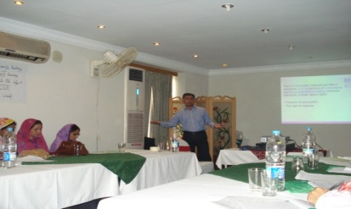
International Labour Organization (ILO) was founded in 1919 under the Treaty of Versailles and was the first specialized agency of United Nations in 1946. Pakistan had become 54th member of the ILO on 31st October 1947 just after the independence.
The International Labour Organization (ILO) is the only tripartite UN agency which brings together Governments, Employers and Workers of its member states in common action to promote Decent Work throughout the World (180 countries).

ILO Convention 182 describes about the Worst Forms of Child Labor. The Government of Pakistan ratified ILO Convention 182 on 11-10-2001. Convention 138 deals with the Minimum Age of a Child for Employment. The Government of Pakistan ratified Convention 138 on 06-07-2006. Copy of the presentation is enclosed herewith Annexure 1

Session 2:

THE PUNJAB DISTITUDE AND NEGLECTED CHILDREN ACT 2004, JUVENILE JUSTICE SYSTEM ORDINANCE 2000 and Other Child Labour Law

(By Mr. Javaid Iqbal Gill, EDO-CD, Sialkot).

Mr. Javaid Iqbal delivered a lecture on the Neglected Children act 2004, Juvenile Justice System Ordinance 2000 and other Child Labour Law. He briefed that the Punjab Neglected Children Act 2004 was an act to consolidate the law for the rescue, protective custody, care and rehabilitation of destitute and neglected children.
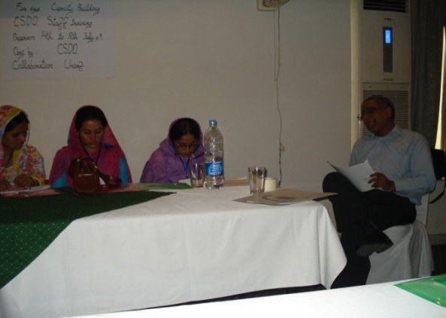
Juvenile Justice System Ordinance (JJSO) is the ordinance that deals with Protection of children involved in criminal litigation, their rehabilitation in society, re-organization of Juvenile Courts and matters connected therewith and incidental thereto. Copy of the presentation is attached herewith. Annexure 2

Session 3:

SOCIAL MOBILIZATION, COMMUNITY ORGANIZATION AND YOUTH GROUP FORMATION

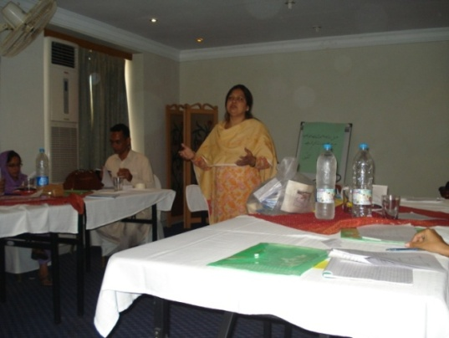
(By Ms. Ghazala Nizami)

In the session, the participants were involved in interactive discussion and group work. Ms. Ghazala Nizami shared the process of Social Mobilization, formation of Community Organization, and Youth Groups.
Social Mobilization is an approach and tool that enables people to organize for collective action, by pooling resources and building solidarity required to resolve common problems and work towards community advancement. She briefed the following four steps of Social Mobilization:-
- Sensitization
- Realization
- Conceptualization
- Organization
Community Organizations are formed to address the issues at local level.
Youth Group might consist of the following: -
- Drop out Children
- Working Children
- Venerable Children
- School going Children
- School teachers
- Parents of working Children
- Children from minorities
- Contractors
At the end of the session the participants were divided into groups and were given the tasks. They made a presentation in which they completed four steps of social mobilization. After completing their work the groups presented their presentations. Participants gave their comments after each presentation. Resource person concluded each discussion and gave suggestions for more betterment.
Copy of the presentation is attached: Annexure 3

Session 4:

NON FORMAL EDUCATION AND MAINSTREAMING OF CHILDREN INTO GOVERNMENT SCHOOLS.

(By Ms. Ghazala Nizami)
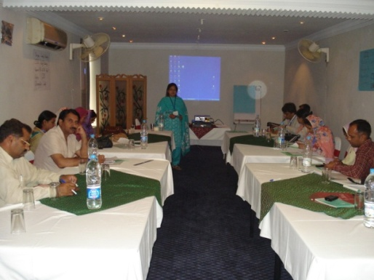
The Resource Person gave the concept of main streaming children into the Government Schools and difference between formal and non-formal schools through power point presentation. She explained the concept and a model of mainstreaming in which guidelines were also explained. The detailed presentation is enclosed. Annexure 4

4.2) Day 2 (15 July 2009)

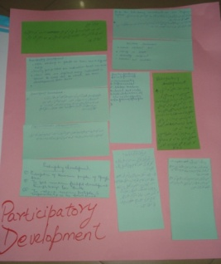
Session 5:

PARTICIPATERY DEVELOPMENT

(By Mr Mujahid Zahoor)

First of all, Mr. Mujahid Zahoor conducted an interesting IQ test with the help of a presentation, with all the participants.

Then the participants were asked to give their views about participatory development on training cards. The cards were displayed in the training hall for the learning of the participants. After that he delivered a lecture on Participatory Rural Appraisal as follows:-
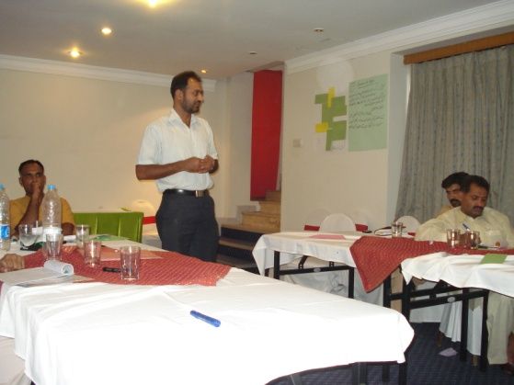
PRA (Participatory Development) is a specific form of a research technique developed in the late 1970s and early 1980s by researches in international development as an alternative to conventional sample surveys. PRA is a way of learning from, and with, community members to investigate, analyze and evaluate constraints and opportunities and make timely decisions, regarding development projects. It is a method by which a research team can quickly and systematically collect information for:
- The general analysis of a specific topic, question, or problem.
- Need assessment.
- Feasibility studies.
- Identifying and prioritizing projects
- Project or programme evaluation
Copy of the presentation is attached herewith. Annexure 5

Session 6:

PROJECT MANAGEMENT

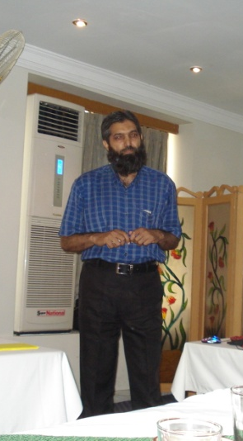
(By Mr. Arshad Mehmood, Research & Development Officer, SCCI)

Salient features of the lecture were as under:-
- Project is a temporary endeavor undertaken to create a unique product or services.
- Project management is about creating an environment conducive to getting critical projects done.
- What are the project boundaries, why projects fail, and succeed and how to break down the work and tasks, most important of all are the role of a project manager and the development of the team. Detailed presentation is attached herewith. Annexure 6

Session 7:

MONITORING TECNIQUE

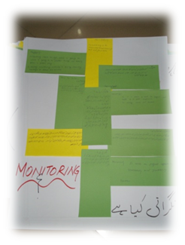
(By Mr. Mujahid Zahoor)

All the participants were asked to give their views about monitoring. Mr Mujahid informed that monitoring is an activity to keep the project on right track. He also briefed about the following two types of monitoring:-
- FIELD MONITORING
- DESK MONITORING

Monitoring could be done on different levels;

- Community Organization Level
- SPO/CPO level
- Field office Level
- Head Office Level

For more detail, coy of the presentation is attached herewith. Annexure # 7

Orientation on the Project Activities

Mr. Mujahid Zahoor gave an orientation on the following project activities:
- Establishment of Technical Committee/ Work Group
- Situation Analysis in Sialkot and its Neighboring Districts
- Memorandum of Understanding
- Establishment of NFE Centers
- Community Mobilization to Organize communities at Child Labour cluster
- Advance vocational Skills
- Mobilization of Private sector for sustainable elimination of child labour and alternative economic opportunities
- Youth/children Group formation for participation and empowerment
- Capacity building of 50 Peer Educators in various child protection issues including life skills
- Monitoring of project activities for smooth implementation of project activities.

Session 8:

LIFE SKILL BASED EDUCATION

(By Ms. Ghazala Nizami)

Resource persons started this session by explaining word skill with some daily life examples and delightfully shared its importance. She shared that a teacher can be imparting these skills in children with her effective teaching method. It was further explained and advised them that they can relate these skills with their curriculum and their daily life situation.

The participants were briefed about the under-mentioned ten core points of Life Skill Based Education:-
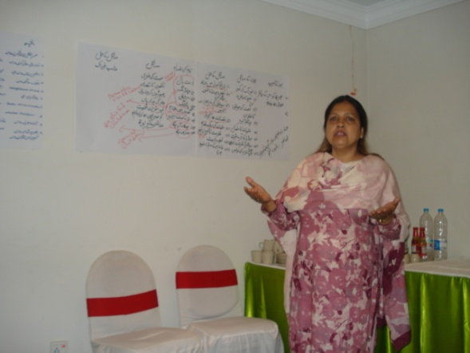
- Decision Making
- Problem Solving
- Self-Awareness
- Communication
- Creative Thinking
- Critical Thinking
- Empathy
- Copying with Stress
- Interpersonal Relationship
- Copying with Emotions
For more detail: Annexure 8

4.3) Day 3 (16 July 2009)

Session 9: COMMUNICATION SKILLS

(By Ms. Ghazala Nizami)

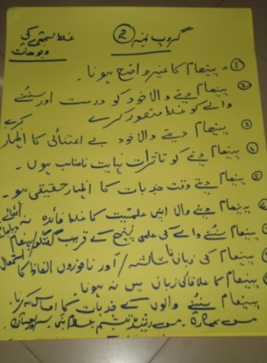
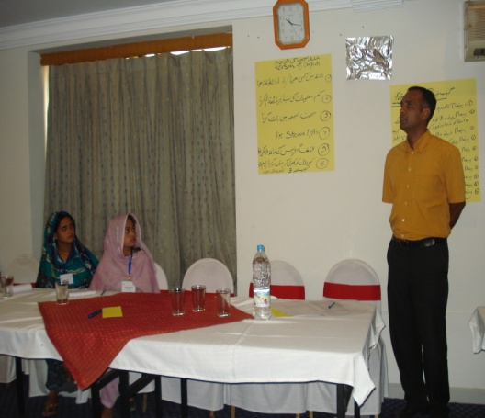
In this session, three Groups were formed. Each group consisted of around five participants. The Resource Person asked the groups to list “what are communication errors what the conflicts of communication are and how to overcome them”. After that all the groups presented their presentations one by one and all points of the presentations were discussed thoroughly.
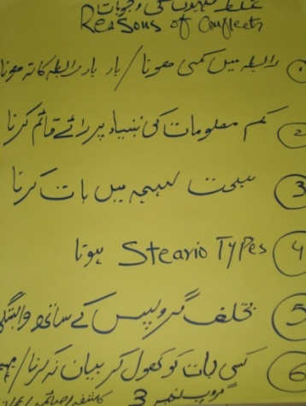

Few flip charts of the group work are depicted above. Copy of the presentation presented by the Resource Person is enclosed. Annexure 9

Session 10:

TIME MANAGEMENT

(By Mr Mujahid Zahoor)

Mr. Mujahid delivered lecture on time management through participatory approach. He shed light on the following ten Priorities for managing time effectively through presentation prepared in power point:-
- Define Goals (You must have clear and well defined goals)
- Set Priorities (Need to determine the importance of each activity)
- Create a “ to do” list (Keep a written record of tasks you have to accomplish for the day)
- Schedule Time (You must schedule time for the work)
- Organize (Organize your work space, your files, your emails)
- Work Smart (Work smart and do the important things in the right way, the first time)
- Delegate (Delegate anything someone else can do. Rely on the people around you)
- Learn to say ‘no’ (Avoid unnecessary tasks that fall outside your range, learn to say ‘no’)
- Manage Meetings (Manage meetings before you take a seat at the table)
- Stay flexible (Create a realistic schedule to avoid overload, and stay flexible)
Detailed presentation is attached herewith. Annexure 10

Session 11:

MOBILIZATION OF PRIVATE SECTOR

(By Mr. Ijaz Ahmed, Project Coordinator, CSDO)

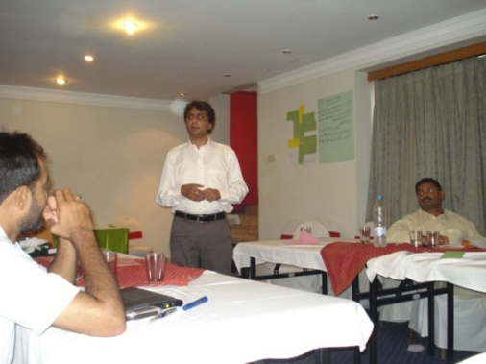
This was also a participatory session. Mr. Ijaz asked the participants “why Social Mobilization of Private Sectors is important for the Project? What is in it for them (business community)?” The participants were briefed that the industrialists might support the Project to fulfill their following dreams:-
  - Projection of the business/enterprise.
  - Becoming part of a unique business community i.e. chances to stand out and earn more business.
- With Fulfillment of social responsibility of a business concern, becoming eligible to do business number of companies/organizations who short list.
- Suppliers/vendors/business partners on this criteria.
- Opportunities to interact with Government officials/policy makers
Copy of the presentation is attached herewith. Annexure 11

Session 12:

PRIVATE PUBLIC PARTNERSHIP

(By Mr. Mohammad Javaid Iqbal Gill, EDO-CD, Sialkot)

The Resource Person described difference between Private Sector and Public Sector. He also shared the role model Projects implemented or being implemented in Sialkot under the Private Public Partnership in Sialkot like establishment of Sialkot International Air Port, City Package for the construction of Roads, etc.

4.4) Day 4 (17 July 2009)

Session 13:

CHILD RIGHTS CONVENTION (CRC)

(By Ms Ghazala Nizami)
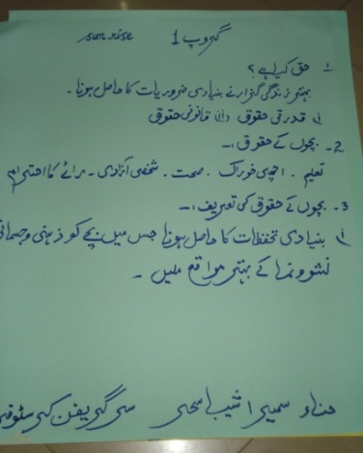
This was a brain storming session. The resource person asked the participants to share their knowledge about the Child Right Convention. After that the resource persons informed the participants about the background of the CRC and shared that why it was needed.
The Resource Person discussed four basic rights of CRC i.e. survival, Protection, Development, Participation. Detailed presentations on the articles of Child Rights Convention were presented before the participants. Copy of the presentation is attached herewith. Annexure 12

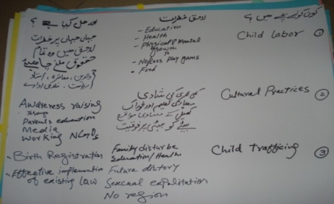
Session14:

COMMUNITY BASED CHILD PROTECTION

(By Ms Ghazala Nizami)

The detail few points presented by the Resource person on the Community Based Child Protection System is as under:
- What is Protection?
- What is Child Protection?
- What is a difference in between Protection and care?
- Types of Children who are in difficult circumstances?
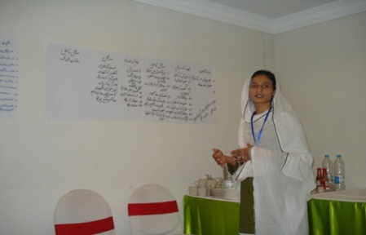
The participants were divided into three groups and were given a task to list the types of threats that children could face in their homes, schools and community, and their solutions. The Participants wrote their views on the charts and the group leaders of the groups presented their presentations one by one. The resource person summed up the discussions.
Copy of the presentation is attached here with Annexure 13

Session 15:

SETTING QUALITY INDICATORS.

(By Ms Ghazala Nizami)

The Resource Person explained the quality indicators for monitoring NFE Centers, Teachers and students.
Three groups of the participants were formed. Each group was given different topic to discuss and make notes on quality indicators. The flip charts prepared by the groups were pasted in the training hall. The resource person summed up the group presentation one by one. The flip charts prepared by the groups are depicted on the next page:-
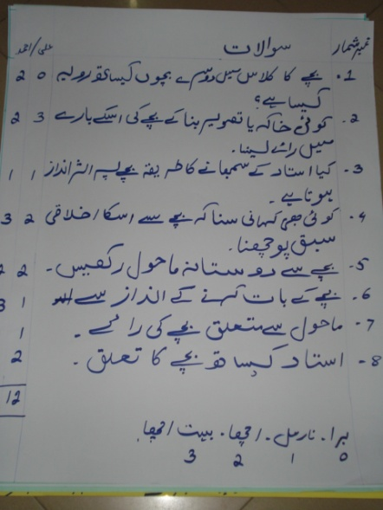
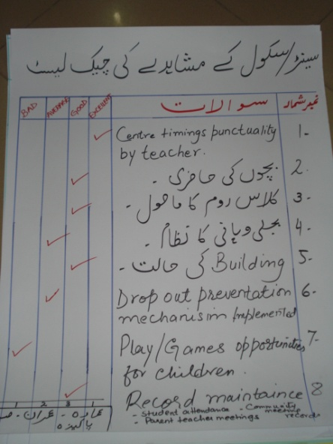
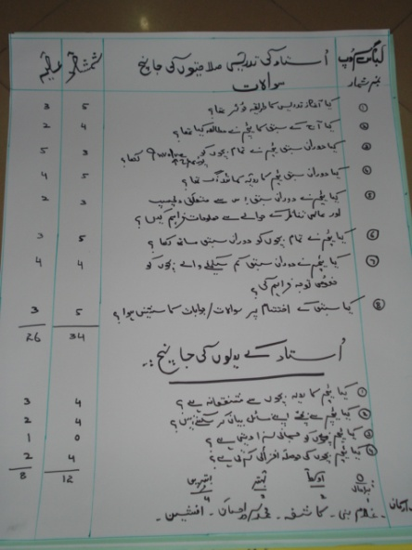

Copy of the presentation presented by the Resource Person is enclosed herewith. Annexure 14

4.5) Day 5 (18 July 2009)

Session 16:

HORIZONTAL AND VERTICAL NETWORKING AT COMMUNITY

(By Mr Mujahid Zahoor)

Mr. Mujahid presented a detailed presentation on Horizontal and Vertical Networking. A practical dialogue was also initiated amongst the Social Organizers to learn how they mobilize the community. The main purpose of the activity was to teach the field staff how they should handle the community and could mobilize them in a better way for the protection of child rights.

Session 17:

TEAM BUILDING

(By Mr Ijaz Ahmed, Project Coordinator, CSDO and Ms. Ghazala Nizami)

This session was divided into two parts i.e. Team Work and Team building. Mr. Ijaz delivered presentation on Team Work and Ms. Ghazala presented a presentation on Team Building.
It was shared that the successful team building requires attention to the following points:-
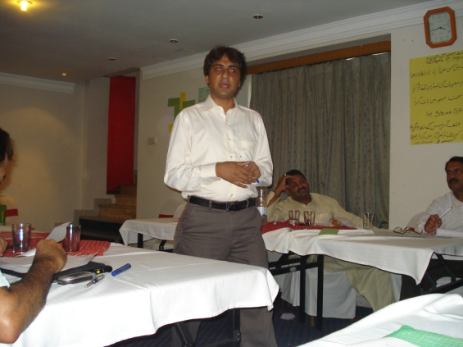
- Clear Expectations
- Context
- Commitment
- Competence
- Charter
- Control
- Collaboration
- Communication
- Creative Innovation
- Consequences
- Coordination
- Cultural Changes
Copy of the presentation is enclosed herewith. Annexure 15

Session 18:

ADVANCE VOCATIONAL SKILLS

(By Mr. Mujahid Zahoor)

This was one of the major activities of the Project signed between UNICEF and CSDO. Mr. Mujahid gave a brief orientation on the topic in the light of the signed PCA. The Methodology of the session was an interactive discussion on appraisals of skills trainings and sustainable micro enterprises.
EVALUATION OF THE WORKSHOP AND POST-TEST

Post-assessment test was conducted in order to evaluate the capacity of the participants after the training.
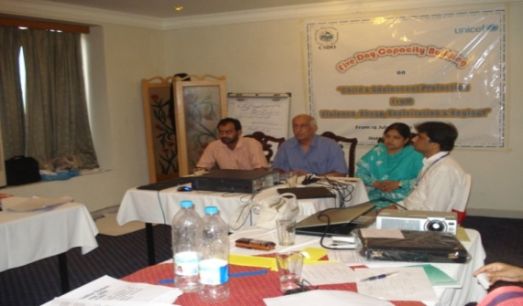
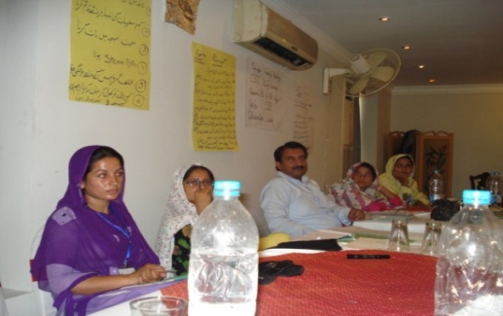
Copies of the pre-test and the post-test taken from the participants are attached as Annexure 16

CLOSING CERMONY OF THE TRAINING

In the end, closing ceremony of 5-day Training Workshop was held. Mir Farooq Meyer, Acting President of CSDO and the Vice President of SCCI thanked UNICEF for their support in organizing capacity building training of CSDO staff. He hoped that participants would have learned a lot during the training which would be helpful for their future professional life. He also thanked Ms. Ghazala Nizami for facilitating the training.
Mr. Mujahid Zahoor, Child Protection Officer informed that Mr. Shamshad Qureshi, Child Protection Specialist, UNICEF, Lahore was supposed to participate in the closing ceremony but he could not come due to some other official commitments. Mr. Mujahid Zahoor thanked all the participants for their active participation and 100% attendance during the course of training. He also whished that the participants would perform their jobs more efficiently using the skills gained in the workshop.
Mr. Ijaz Ahmed, Project Coordinator, CSDO thanked all the participants especially Mr. Mujahid Zahoor and Ms. Ghazala Nizami for their friendly and participatory way of teaching. All the participants were pleased and satisfied with teaching techniqus of the Resource Persons. Mir Farooq Meyer, Mr. Mujahid Zahoor and Ms. Ghazala Nizami awarded training participation Certificates to all the participants
